- [10 points] Explain the differences between primary keys, candidate keys, and superkeys. If each is a set of keys within a table, how are they related to each other?
A primary key is a group of columns in a table that identifies all the rows which differs from a super key which is similar to primary keys except that it uses multiple key’s to identify rows not all of them. A candidate key is like a super key except that doesn’t contain repeated attributes and it identifies tuples within a table. A super key set will contain all the collection of elements which are unique for all the tuples. A candidate key will not have any redundant attributes and is a subset of the super key. The primary key is one of the candidate key’s that is chosen by the programmer as an instance of the candidate key.

- a. [15 points] Construct an (E)ER diagram for a hospital system with the following requirements:
- Patients are described using unique ss# as well as name, insurance, admitted date, and checked-out date
- Doctors are described using unique dss# as well as their names and specialization.
- Each patient may have a set of tests, described by test id, test name, date, time, and results.
- These tests are performed by doctors.

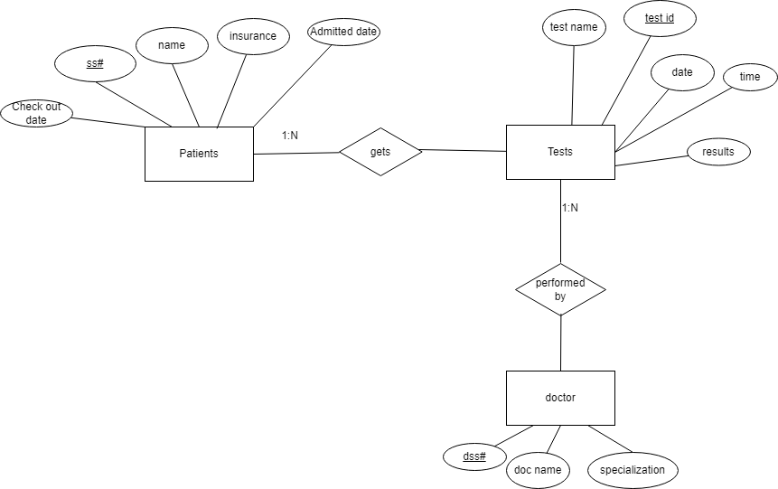

- b. [15 points] Then convert the (E)ER diagram to a collection of relation tables. Determine all the primary and foreign keys.

Patient(patient_ID/ss#, insurance , name, check in date, check out date)
primary key: {patient_ID/ss#}
foreign key: test_id

Doc(Doc_ID/dss#, doc name, specialization)
primary key: {doc_ID/dss#}
foreign key: test_id

test(test_id, test name, date, time, results)
primary key: {test_id}
foreign key: patient_ID from patient, doc_ID from Doc

- [5 points] What is the difference between a weak and strong entity set? What is the purpose of having a weak entity set?
Weak entities which are represented by a one box rectangle are dependent on a strong entity and don’t have primary keys whilst a strong entity is not dependent and contain a primary key. The purpose of weak entities is to avoid inconsistencies caused by duplicating strong keys as well as the fact that weak entities have total participation which you may need in you relationship set.

- Suppose the Publication schema with the specified functional dependencies.
Publication (Title, Author, Book_type, Author_affil, ISBN)
The functional dependencies hold for this schema:
Title -> Author, Book_type
Book_type,Author_affil -> ISBN
Author-> Author_affil
ISBN -> Title
- [10 points] What is the highest normal form it is in?
3NF
b. [15 points] Find a lossless-join decomposition into BCNF for the Publication schema.
(Author->Author_affil), (ISBN,Title), (Title, Author, Book_type)
5. [30 points] Consider the universal relation
R = (A, B, C, D, E, F, G, H, I, J)
and the set of functional dependencies
A, B -> C
B, D -> E, F
A, D -> G, H
A -> I
H -> J
What is the key for R? Decompose R into 2NF, and then into 3NF relations.
Key for R = {A,B}
R1{A,D,G,H,I,J} R2{B,D,E,F} R3{A,B,C} 2NF decomp
R11{A,D,G,H,} R12{A,I} R13{H,J} R21{B,D,E,F} R3{A,B,C} 3NF decomp

